Snowflake has:

* Rapidly Changing Dimension (RCD)- is a dimension which has attributes where values will be getting changed often
* Slowly Changing Dimension (SCD)- is a concept in data warehousing and database management that deals with managing changes to dimension data over time.

SCD has three types: Type 1, Type 2, Type 3

* Unchanging Dimension(UCD)-

create table Employee(EmpName varchar(100),empdob date, empgender varchar(100), emploc varchar(100), empcontactno number(20,0) primary key);

insert into Employee Values('Ram Kumar','01-JAN-1990','Male','Bangalore','7898528527');

insert into Employee values('Sunita','02-FEB-1991','Female','Bangalore','951753825');

insert into Employee values('Ajay','01-FEB-1985','Male','Hyderabad','9638527415');

insert into Employee values('Nitin','05-FEB-1991','Male','Chennai','8527539515');

##D_Employee table is for SCD type 1##

create table D_Employee(PK_Employee_Key int primary key,econtactno NUMBER(20,0),EName varchar(100),edob date, egender varchar(100), eloc varchar(100),created_date date,updated_date date);

insert into D_Employee values(1,'7898528527','Ram Kumar','01-JAN-1990','Male','Bangalore',sysdate,NULL);

insert into D_Employee values(2,'951753825','Sunita','02-FEB-1991','Female','Bangalore',sysdate,NULL);

insert into D_Employee values(3,'9638527415','Ajay','01-FEB-1985','Male','Hyderabad',sysdate,NULL);

insert into D_Employee values(4,'8527539515','Nitin','05-FEB-1991','Male','Chennai',sysdate,NULL);

update Employee set emploc='Pune' where empcontactno='8527539515';

update D_Employee set eloc='Pune' where PK_Employee_Key=4;

UPDATE D_Employee set updated_date=sysdate where PK_Employee_Key=4;

Type 2:

create table D2_Employee(PK_Employee_Key int primary key,econtactno NUMBER(20,0),EName varchar(100),edob date, egender varchar(100), eloc varchar(100),start_date date,end_date date, version int, flag varchar(5));

insert into D2_Employee values(1,'7898528527','Ram Kumar','01-JAN-1990','Male','Bangalore',sysdate,NULL,1,'Y');

insert into D2_Employee values(2,'951753825','Sunita','02-FEB-1991','Female','Bangalore',sysdate,NULL,1,'Y');

insert into D2_Employee values(3,'9638527415','Ajay','01-FEB-1985','Male','Hyderabad',sysdate,NULL,1,'Y');

insert into D2_Employee values(4,'8527539515','Nitin','05-FEB-1991','Male','Chennai',sysdate,NULL,1,'Y');

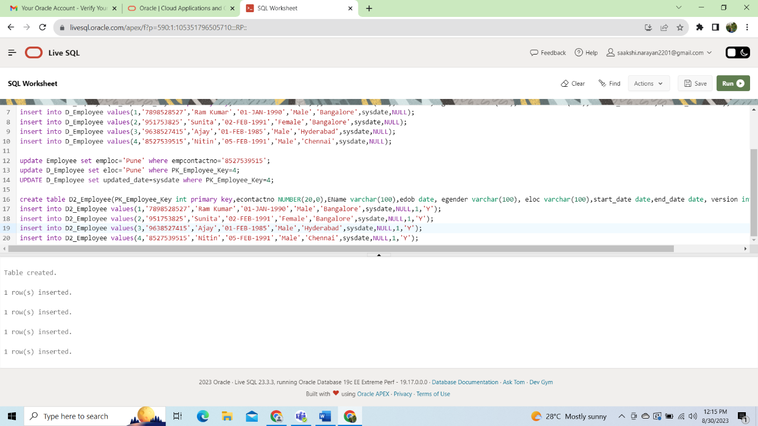

HDFS is designed to reliably store very large files across machines in large cluster. It stores each file as sequence of nodes. The logs of a file are replicated for fault tolerance.